*MINI PROJECT*

*PRINTING TRANSPOSE OF MATRIX*

#include <stdlib.h>

typedef struct vec_int_2d {

int *element_ptr;

int row_count;

int col_count;

} Vec_int_2d;

Vec_int_2d create_2d_vec(int row_count, int col_count);

int get_element_2d_vec(Vec_int_2d vec, int row_index, int col_index);

void set_element_2d_vec(Vec_int_2d vec, int row_index, int col_index,

int value);

Vec_int_2d create_2d_vec(int row_count, int col_count) {

Vec_int_2d return_vec = {

.element_ptr = (int *)malloc((row_count * col_count) * sizeof(int)),

.row_count = row_count,

.col_count = col_count,

};

return return_vec;

}

int get_element_2d_vec(Vec_int_2d vec, int row_index, int col_index) {

return vec.element_ptr[row_index * vec.col_count + col_index];

}

void set_element_2d_vec(Vec_int_2d vec, int row_index, int col_index,

int value) {

vec.element_ptr[row_index * vec.col_count + col_index] = value;

}

// Program to Find the Transpose of a Matrix

#include <stdio.h>

int main() {

Vec_int_2d a, transpose;

int r, c, user_input_iterator;

printf("Enter rows and columns: ");

scanf("%d %d", &r, &c);

a = create_2d_vec(r, c);

transpose = create_2d_vec(c, r);

printf("\nEnter matrix elements:\n");

for (int i = 0; i < r; ++i)

for (int j = 0; j < c; ++j) {

printf("Enter element a%d%d: ", i + 1, j + 1);

scanf("%d", &user_input_iterator);

set_element_2d_vec(a, i, j, user_input_iterator);

}

printf("\nEntered matrix: \n");

for (int i = 0; i < r; ++i)

for (int j = 0; j < c; ++j) {

printf("%d ", get_element_2d_vec(a, i, j));

if (j == c - 1)

printf("\n");

}

for (int i = 0; i < r; ++i)

for (int j = 0; j < c; ++j) {

set_element_2d_vec(transpose, j, i, (get_element_2d_vec(a, i, j)));

}

printf("\nTranspose of the matrix:\n");

for (int i = 0; i < c; ++i)

for (int j = 0; j < r; ++j) {

printf("%d ", get_element_2d_vec(transpose, i, j));

if (j == r - 1)

printf("\n");

}

return 0;

}

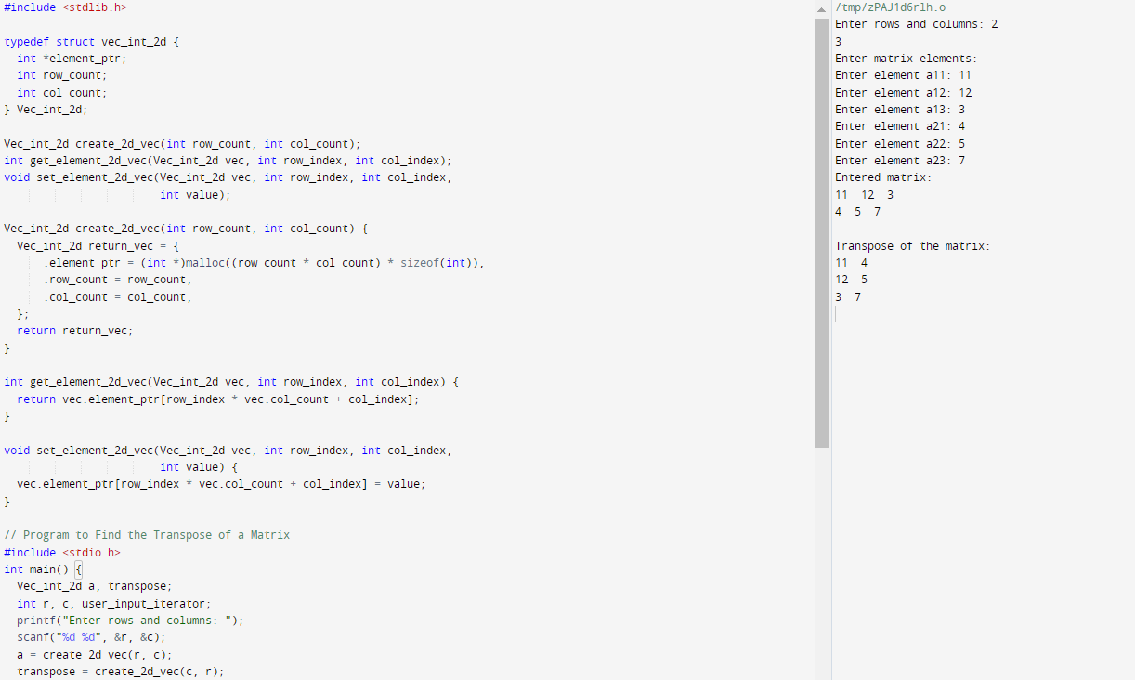

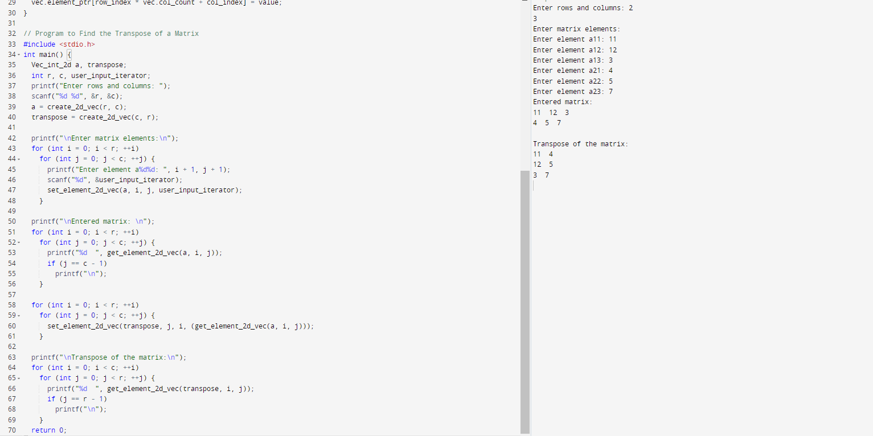

NAME:Y.PUNITH CHOWDARY

REG NO:RA2111003011010

SECTION:D2